TRIBHUVAN UNIVERSITY
PATAN MULTIPLE CAMPUS
PATANDHOKA, LALITPUR

SUBMITTED BY: | SUBMITTED TO:
NAME: SURESH DAHAL | SHIB KUMAR MAHATO
CLASS: BIT II/II
ROLL NO.:23 | _________________________
DATE: __________________ | CHECKED BY
BIT 253 SYSTEM ANALYSIS AND DESIGN

TITLE: ENTITY-RELATIONSHIP DIAGRAM USING DRAW.IO
THEORY:
An Entity Relationship Diagram is a visual representation of data and the relationships among them in a system. It helps in designing a clear and structured database model using symbols such as rectangles for entities, ovals for attributes, and diamonds for relationships.
- ER Diagram of Banking Information System
The Entity Relationship Diagram for the Bank Information System shows the structure and interaction between customers, accounts, employees, branches, admins, and transactions within the banking environment.

Key Components:
Entities: Customer, Account, Transaction, Employee, Branch, Admin
Relationships:
- Customer Owns Account
- Account Performs Transaction
- Employee Authorizes Transaction
- Employee Works in Branch
- Admin Manages Branch
Attributes:
- Customer: id, name, address, contact, email
- Account: ac_no, type, balance, customer_id
- Transaction: t_id, type, date, amount, e_id, ac_no
- Employee: e_id, name, position, contact, branch_id
- Branch: branch_id, name, location, admin_id
- Admin: admin_id, username, password, role
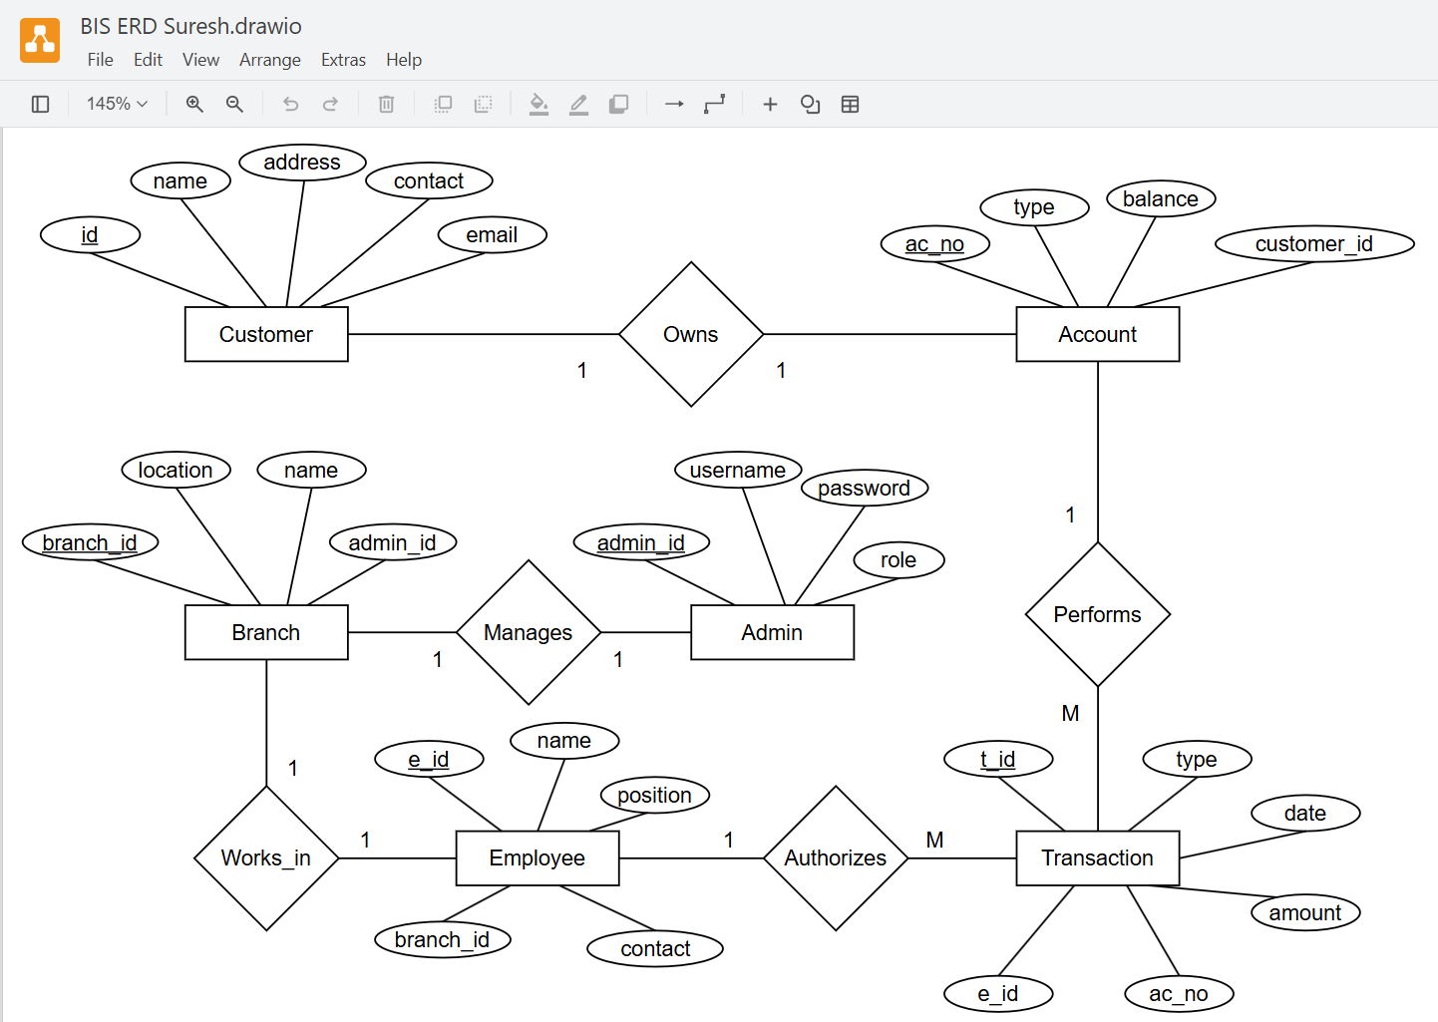

- ER Diagram of Employee Management System
The Entity Relationship Diagram for the Employee Management System represents the key entities and their relationships involved in managing employee details, salaries, depart-ments, designations, attendance, and administrative roles.

Key Components:
Entities: Employee, Salary, Department, Designation, Attendance, Admin
Relationships:
- Employee Receives Salary
- Employee Belongs to Department
- Employee Holds Designation
- Employee Marks Attendance
- Admin Manages Department
Attributes:
- Employee: emp_id, name, gender, contact_no, email, address, dob
- Salary: salary_id, basic_pay, allowances, deductions, net_salary
- Department: dept_id, name, location
- Designation: designation_id, title, description
- Attendance: id, date, status
- Admin: admin_id, username, password, role
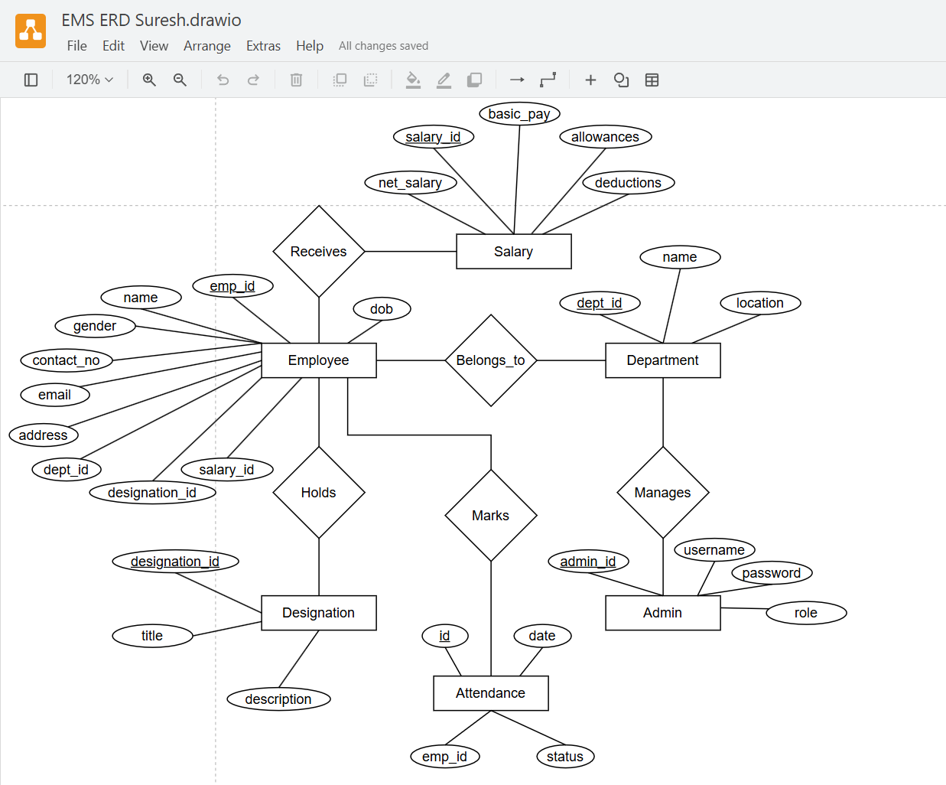
- ER Diagram of Library Management System
The Entity Relationship Diagram for the Library Management System represents the key entities and their relationships involved in managing library, member registration, borrowing books, and maintaining supplier records etc.

Key Components:
Entities: Member, Book, Supplier, Librarian, Transaction, Book_Order
Relationships:
- Member Borrows Books
- Librarian Manages Transactions
- Supplier Supplies Book_Order
- Book_Order Includes Books
Attributes:
- Member: id, join_date, name, address, phone, fine_amount
- Book: book_id, title, author, status, category, ISBN, shelf_no
- Librarian: librarian_id, username, password, name, phone
- Transaction: id, date_issued, date_returned, due_date, fine, status
- Supplier: supplier_id, email, name, address, phone
- Book_Order: order_id, order_date, amount, status

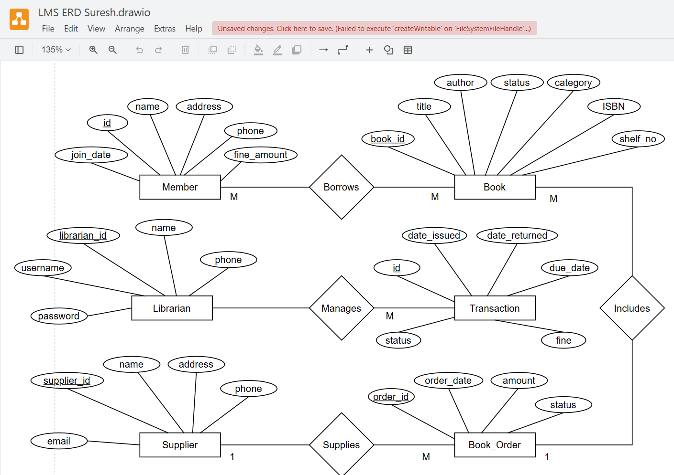

TITLE: CONTEXT DIAGRAM USING DRAW.IO
THEORY:
A Context Diagram is a high-level data flow diagram that shows a system as a single process and illustrates its interaction with external entities such as users, organizations, or other systems. It helps in understanding the system boundaries, inputs, and outputs without going into internal details.
  - CONTEXT DIAGRAM OF BANKING INFORMATION SYSTEM
A Data Flow Diagram (DFD) Level 0 for a "Banking Information System" provides the highest-level overview, showing the entire system as a single process and its interactions with external entities.

Key Components:
Entities: Admin, Bank Employee, Customer, External System
Process:
- Banking Information System
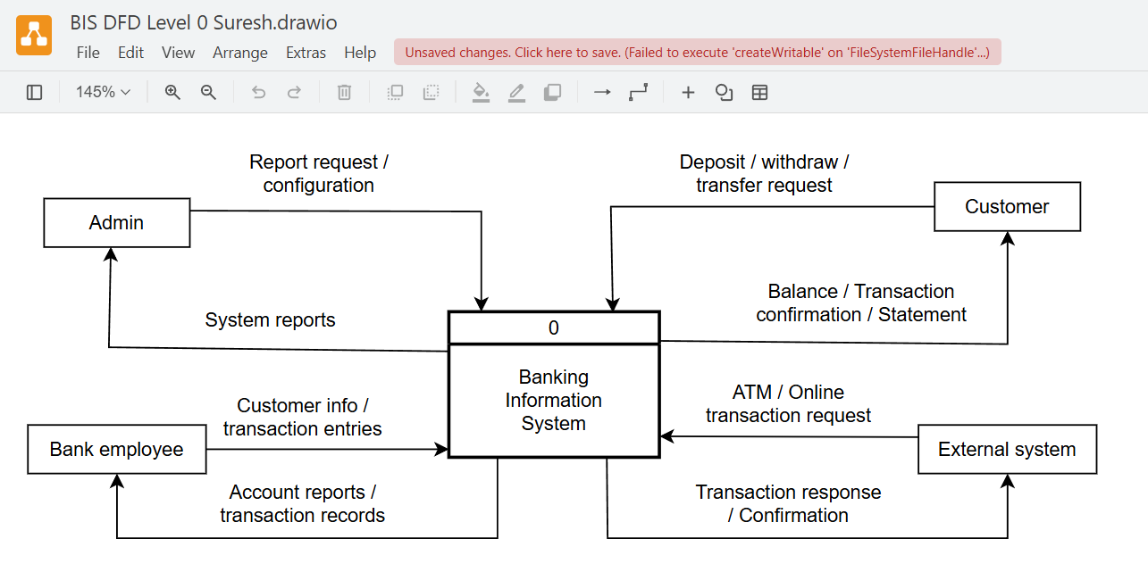
- CONTEXT DIAGRAM OF EMPLOYEE MANAGEMENT SYSTEM
A Data Flow Diagram (DFD) Level 0 for a "Employee Management System" provides the highest-level overview, showing the entire system as a single process and its interactions with external entities.

Key Components:
Entities: Employee, Admin, Payroll Department
Process:
- Employee Management System
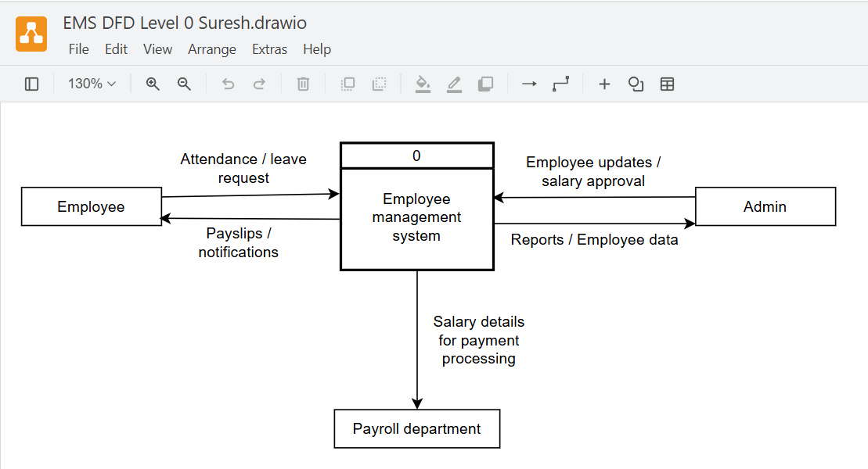
- CONTEXT DIAGRAM OF LIBRARY MANAGEMENT SYSTEM
A Data Flow Diagram (DFD) Level 0 for a "Library Management System" provides the highest-level overview, showing the entire system as a single process and its interactions with external entities.
Key Components:
Entities: Member, Admin, Supplier, Librarian
Process:
- Library Management System

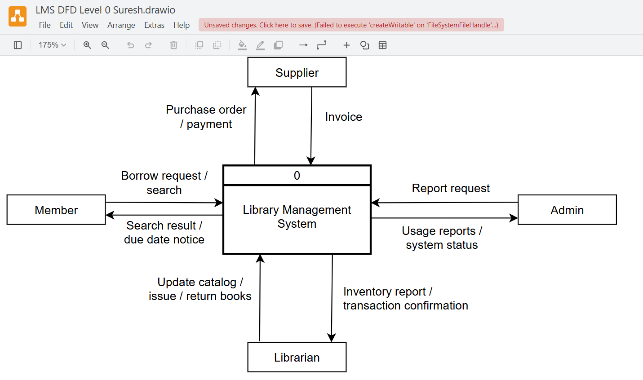
TITLE: LEVEL 1 DFD USING DRAW.IO
THEORY:
A Level 1 Data Flow Diagram (DFD) is an expanded version of the context-level DFD that breaks down the main process into sub-processes. It shows how data moves between these sub-processes, data stores, and external entities.
  - LEVEL 1 DFD OF BANKING INFORMATION SYSTEM
A Data Flow Diagram (DFD) Level 1 for a Banking Information System provides a detailed view of the main processes within the system, illustrating how data flows between various components.
Key Components:
Entities: Employee, Admin, Payroll Department
Data Stores:
- Employee
- Attendance
- Salary
Process:
- Employee Management
- Attendance Management
- Salary Management
- Generate Reports
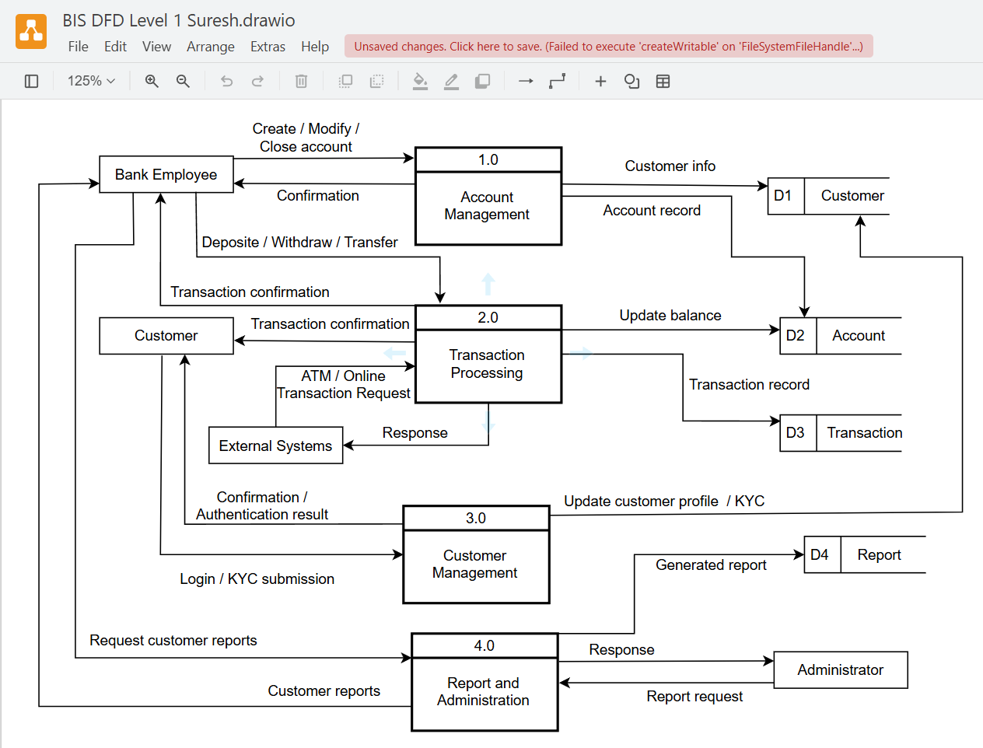
  - LEVEL 1 DFD OF EMPLOYEE MANAGEMENT SYSTEM
A Data Flow Diagram (DFD) Level 1 for a Employee Management System provides a detailed view of the main processes within the system, illustrating how data flows between various components.

Key Components:
Entities: Bank Employee, Customer, Administrator
Data Stores:
- Customer
- Account
- Transaction
- Reports
Process:
- Account Management
- Transaction Processing
- Customer management
- Report and Administration

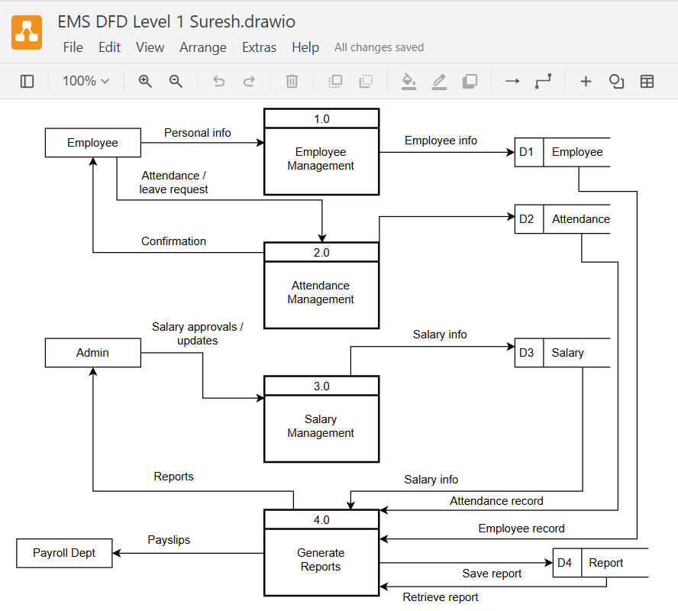

  - LEVEL 1 DFD OF LIBRARY MANAGEMENT SYSTEM
A Data Flow Diagram (DFD) Level 1 for a Library Management System provides a detailed view of the main processes within the system, illustrating how data flows between various components.

Key Components:
Entities: Member, Librarian, Admin, Supplier
Data Stores:
- Book
- Member
- Transaction
- Supplier
Process:
- Book Catalog Management
- Circulation Management
- Member Management
- Supplier Management

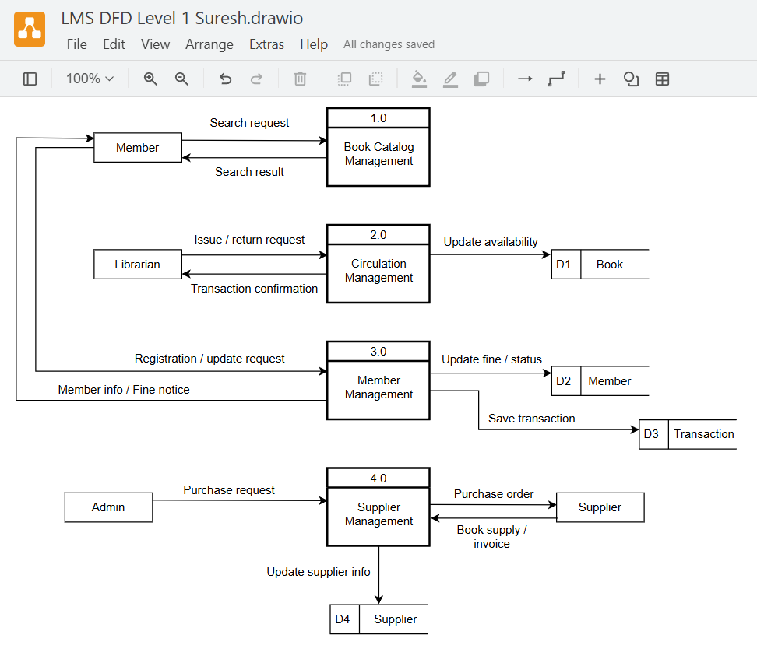
TITLE: LEVEL 2 DFD USING DRAW.IO
THEORY:
A Level 2 Data Flow Diagram (DFD) is a further detailed breakdown of the Level 1 processes. It shows how each sub-process works internally and how data flows between them.
It provides a clearer view of system logic, data inputs, outputs, and interactions between small modules.
- LEVEL 2 DFD OF BANKING INFORMATION SYSTEM
Key Components:
Entities: Customer, Bank Employee
Data Stores: Account, Transaction
Sub-process (Transaction Processing):
- Deposit Processing
- Withdrawal Processing
- Fund Transfer
- Transaction Record Management
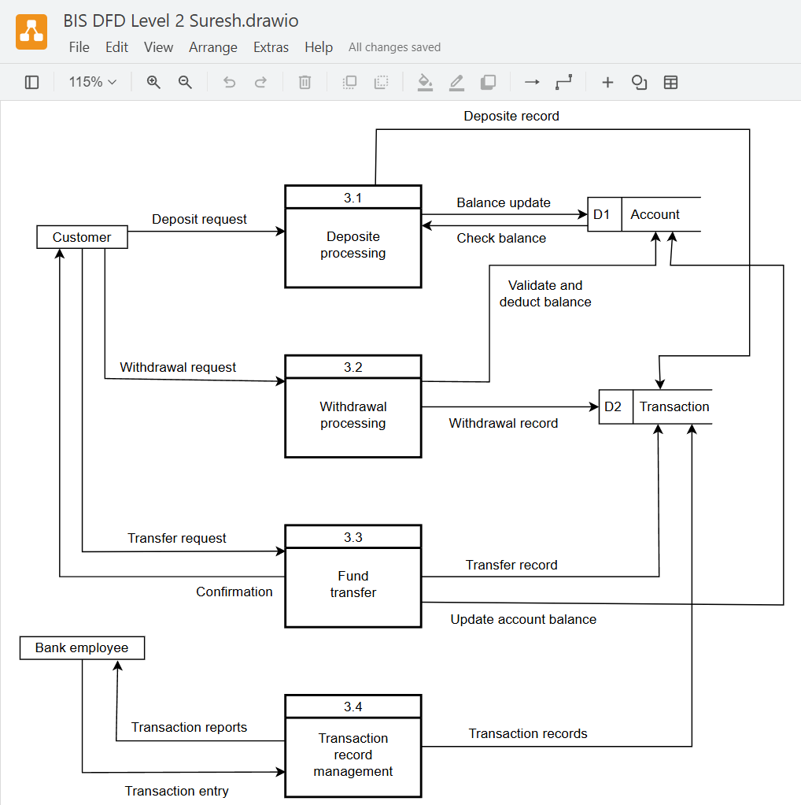
  - LEVEL 2 DFD OF EMPLOYEE MANAGEMENT SYSTEM
A Level 2 Data Flow Diagram of the Employee Management System provides a detailed view of the internal processes of Level 1 components. It breaks down major processes into smaller sub-processes to show how data flows among them.

Key Components:
Entities: Employee, Admin
Data Stores:
- Attendance
- Leave
Sub-process (Attendance Management):
- Record Attendance
- Apply Leave
- Approve Leave

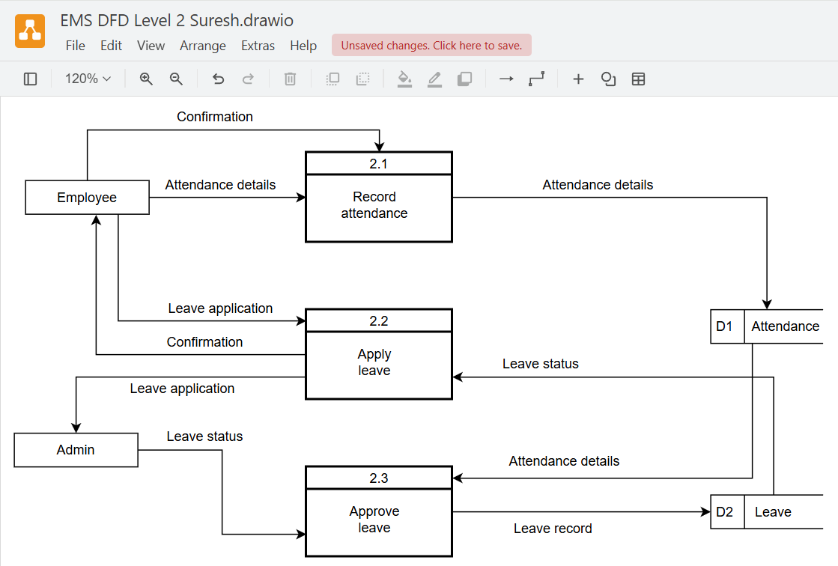

  - LEVEL 2 DFD OF LIBRARY MANAGEMENT SYSTEM
A Level 2 Data Flow Diagram of the Library Management System provides a detailed view of the internal processes of Level 1 components. It breaks down major activities into smaller sub-processes to show how data flows among them.

Key Components:
Entities: Member, Librarian
Data Stores:
- Book
- Member
- Transaction
Sub-process (Circulation Management):
- Check Book Availability
- Issue Book
- Return Book
- Review Book
